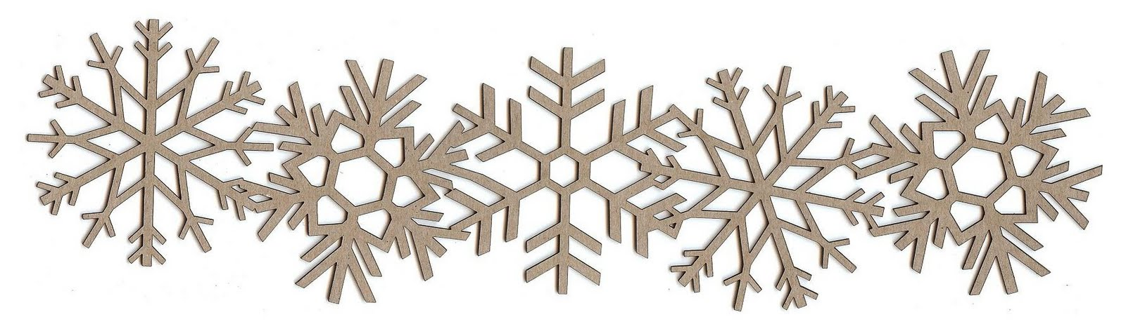
2018
Last Spring and First Fall Frosts

For Nashville, your 50% risk of frost is from November 9 through March 30
Almost certainly (90%) you will receive frost from November 26 through March 16.
You are very unlikely to receive frost from April 14 through October 23.
(See attached data for surrounding areas/percentages.)

Last spring frost: March 30

Weeks Last Weeks
Before Spring After
Frost
10 8 6 4 2 0 2 4 6 8
1/19 2/2 2/16 3/2 3/16 3/30 4/13 4/27 5/11 5/25

First fall frost: Nov. 9

Weeks First Weeks
Before Fall After
Frost
10 8 6 4 2 0 2 4 6 8
8/31 9/14 9/28 10/12 10/26 11/9 11/23 12/7 12/21 1/4

Station Data from the National Climatic Data Center

Your results

Each winter, on average, your risk of frost is from November 9 through March 30.
Almost certainly, however, you will receive frost from November 26 through March 16.
You are almost guaranteed that you will not get frost from April 14 through October 23.
Your frost-free growing season is around 224 days.

Detailed station data* follows:

Nashville Peach Substn, AR (Howard county):
Temperature | 10% | 20% | 30% | 40% | 50% | 60% | 70% | 80% | 90%
Spring 32° | Apr 14 | Apr 9 | Apr 5 | Apr 2 | Mar 30 | Mar 27 | Mar 24 | Mar 21 | Mar 16
Spring 28° | Apr 5 | Mar 30 | Mar 26 | Mar 22 | Mar 18 | Mar 15 | Mar 11 | Mar 6 | Feb 28
Spring 24° | Mar 22 | Mar 14 | Mar 8 | Mar 3 | Feb 26 | Feb 22 | Feb 17 | Feb 11 | Feb 3
Fall 32° | Oct 23 | Oct 29 | Nov 1 | Nov 5 | Nov 9 | Nov 12 | Nov 16 | Nov 20 | Nov 26
Fall 28° | Oct 27 | Nov 2 | Nov 8 | Nov 12 | Nov 17 | Nov 21 | Nov 26 | Dec 2 | Dec 10
Fall 24° | Nov 6 | Nov 14 | Nov 19 | Nov 24 | Nov 29 | Dec 4 | Dec 9 | Dec 15 | Dec 23

De Queen, AR (Sevier county):
Temperature | 10% | 20% | 30% | 40% | 50% | 60% | 70% | 80% | 90%
Spring 32° | Apr 14 | Apr 9 | Apr 5 | Apr 2 | Mar 30 | Mar 27 | Mar 24 | Mar 20 | Mar 15
Spring 28° | Apr 3 | Mar 27 | Mar 23 | Mar 19 | Mar 15 | Mar 11 | Mar 7 | Mar 2 | Feb 24
Spring 24° | Mar 20 | Mar 13 | Mar 7 | Mar 3 | Feb 26 | Feb 22 | Feb 17 | Feb 12 | Feb 4
Fall 32° | Oct 19 | Oct 24 | Oct 28 | Oct 31 | Nov 3 | Nov 6 | Nov 10 | Nov 14 | Nov 19
Fall 28° | Oct 28 | Nov 2 | Nov 6 | Nov 10 | Nov 13 | Nov 17 | Nov 20 | Nov 25 | Dec 2
Fall 24° | Nov 5 | Nov 13 | Nov 19 | Nov 23 | Nov 28 | Dec 3 | Dec 8 | Dec 14 | Dec 22

Murfreesboro 2, AR (Pike county):
Temperature | 10% | 20% | 30% | 40% | 50% | 60% | 70% | 80% | 90%
Spring 32° | Apr 16 | Apr 10 | Apr 6 | Apr 3 | Mar 31 | Mar 28 | Mar 25 | Mar 21 | Mar 16
Spring 28° | Apr 7 | Apr 1 | Mar 27 | Mar 24 | Mar 20 | Mar 17 | Mar 13 | Mar 9 | Mar 3
Spring 24° | Mar 20 | Mar 13 | Mar 9 | Mar 5 | Mar 1 | Feb 25 | Feb 21 | Feb 17 | Feb 10
Fall 32° | Oct 25 | Oct 29 | Oct 31 | Nov 3 | Nov 5 | Nov 8 | Nov 10 | Nov 13 | Nov 18
Fall 28° | Oct 30 | Nov 4 | Nov 8 | Nov 12 | Nov 15 | Nov 19 | Nov 23 | Nov 27 | Dec 4
Fall 24° | Nov 8 | Nov 15 | Nov 20 | Nov 25 | Nov 29 | Dec 4 | Dec 8 | Dec 13 | Dec 20
* This station data is available courtesy the National Climatic Data Center.
For each weather station, you will see a temperature along with tables of data organized into percentage columns. The percentage column tells you the probability that you will experience that row's temperature on or near that date. Here are two examples to help you determine your probable last frost and first freeze dates.
Example 1 (Last Frost). In the Spring 32° row, if you have "Apr 15" under the 50% column, that means you have a 50% chance of seeing frost on or before April 15th.
Example 2 (First Freeze). In the Fall 24° row, if you have "Dec 1" under the 90% column, that means you have a 90% chance of seeing 24 degrees on or after December 1st.
Empty cells indicate you have a less than 10% chance of ever seeing that temperature.
Source: https://davesgarden.com/guides/freeze-frost-dates/index.php?q=71852&submit=Go

30-Year Average Data Maps
Source: https://www.ncdc.noaa.gov/sites/default/files/Day-of-Last-Spring-Freeze-Map.jpg

